**Module-2: Case Study**

**Problem Statement:**

You work for XYZ Corporation. Your corporation is working on an application and they require secured web servers on Linux to launch the application.

**You have been asked to:**

1. Create an Instance in us-east-1 (N. Virginia) region with Linux OS and manage the requirement of web servers of your company using AMI

2. Replicate the instance in us-west-2 (Oregon) region

3. Build two EBS volumes and attach them to the instance in us-east-1 (N. Virginia) region

4. Delete one volume after detaching it and extend the size of other volume

5. Take backup of this EBS volume.

**Problem 1 Solution:** Create an Instance in us-east-1 (N. Virginia) region with Linux OS and manage the requirement of web servers of your company using AMI

**Step 1: Login** into your **“AWS Console”** & **Choose** the **“US East (N.Virginia)”** region**.**

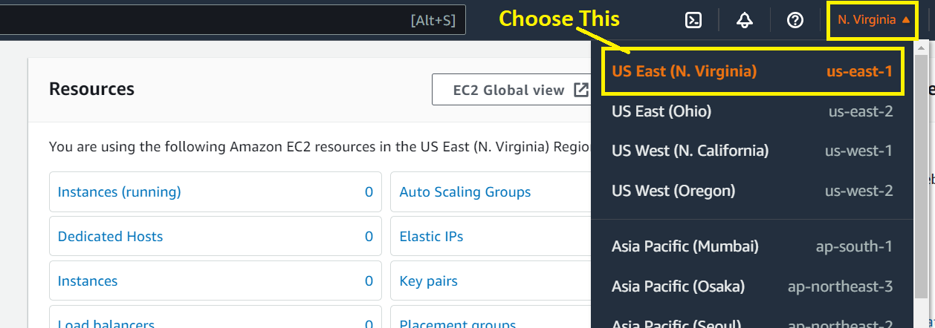

**Step 2: Click** on the **“Instances (running)”.**

**s**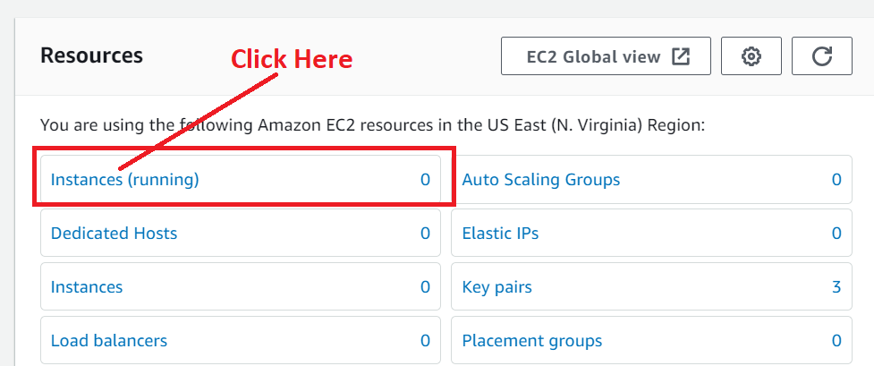

**Step 3: Click** onthe **“Launch Instance”.**

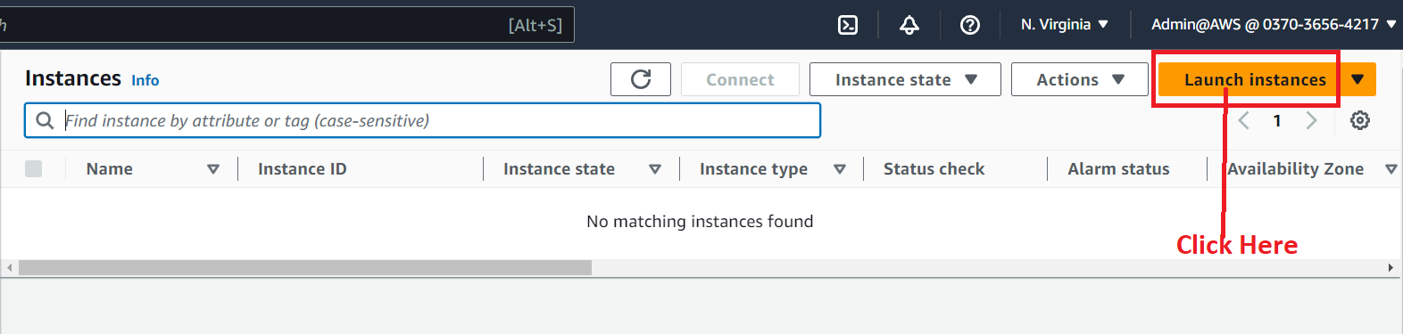

**Step 4: Choose** the **Name** as **“Task1-Apache2-Case-Study”** inthe **“Name”** under the **“Name and tags”** section.

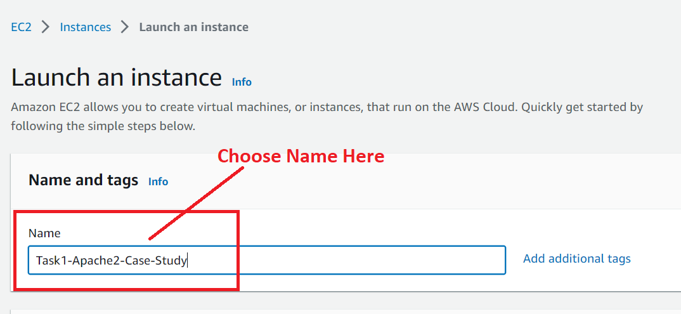

**Step 5: Choose** the **“Amazon Machine Image” (AMI)** as **“Ubuntu”.**

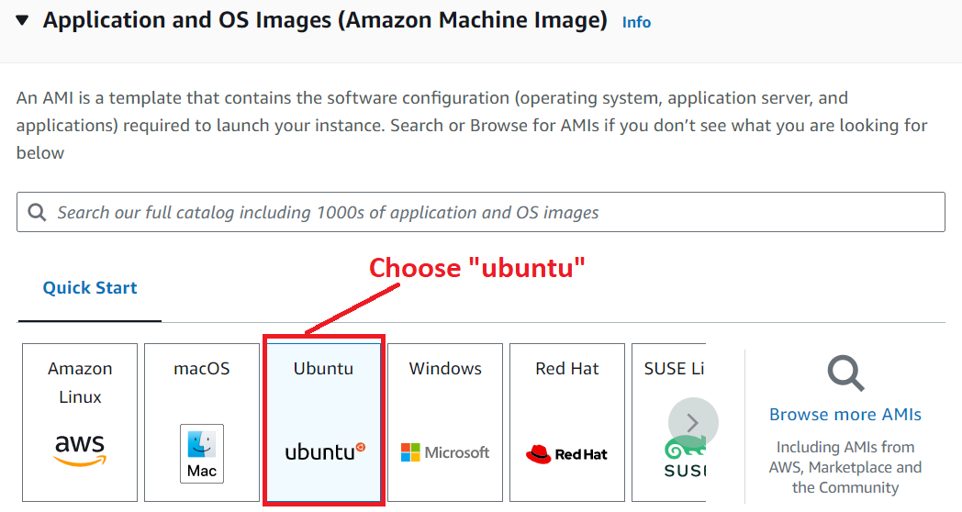

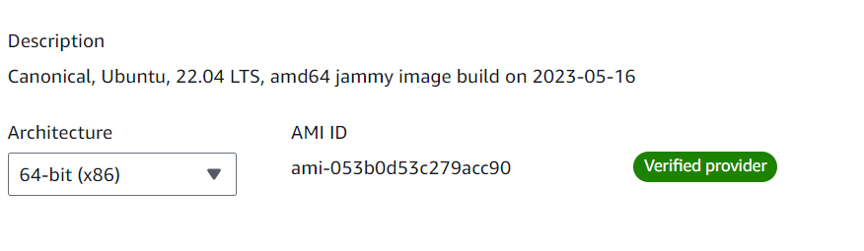

**Step 6: Choose** the **“Instance Type”** as **“t2.micro”.**

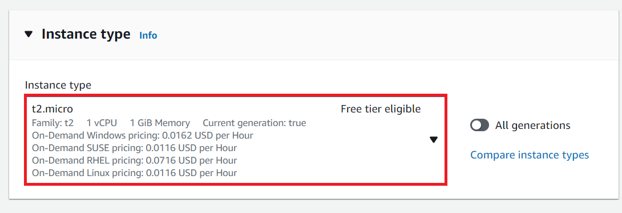

**Step 7: Follow** these **steps** to **create** a **key pair:**

**a. Click** onthe **“Create new key pair”.**

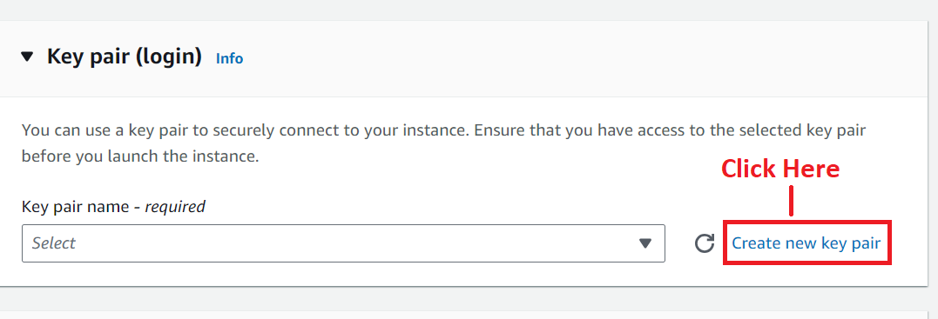

**b. Choose** the **“Key pair name”** asthe **“Task1-Apache2-Case-Study”. While choose** the **“Key pair type”** as **“RSA”** & **select** the **“Private key file format”** as **“.pem”. Click** onthe **“Create key pair”.**

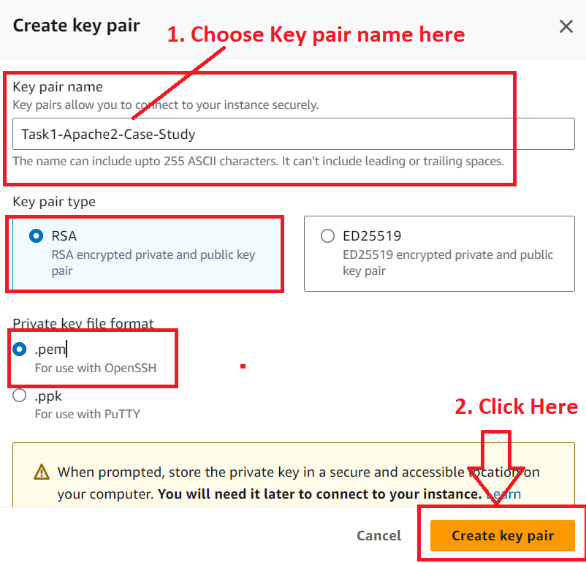

**c.** The **“.pem” file** will be **downloaded.**

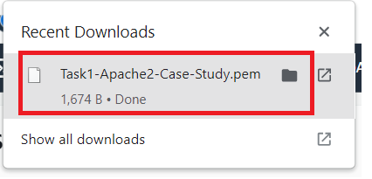

**d. The key pair** will be **successfully created.**

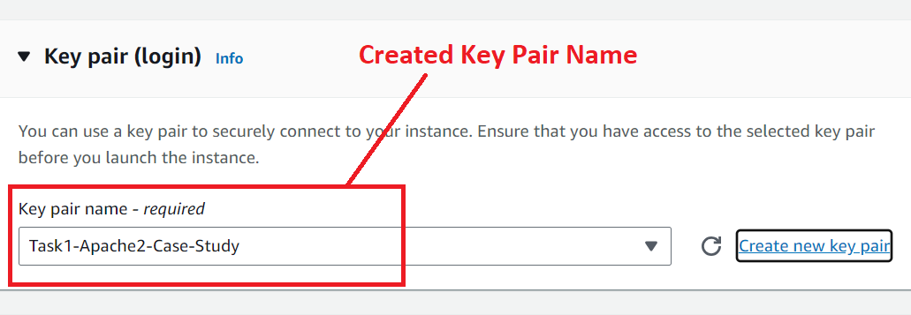

**Step 8: Follow** these **steps** to **create** a **new security group:**

**(A). In** the **“Network Settings”, you will notice the firewall. In** the **“Firewall (security groups)”, choose** the **“Create security group”** option**.** After **choosing** the **firewall, select** these **traffic rules:**

1. **Allow SSH Traffic from “Anywhere”.**
2. **Allow HTTP traffic from the internet.**

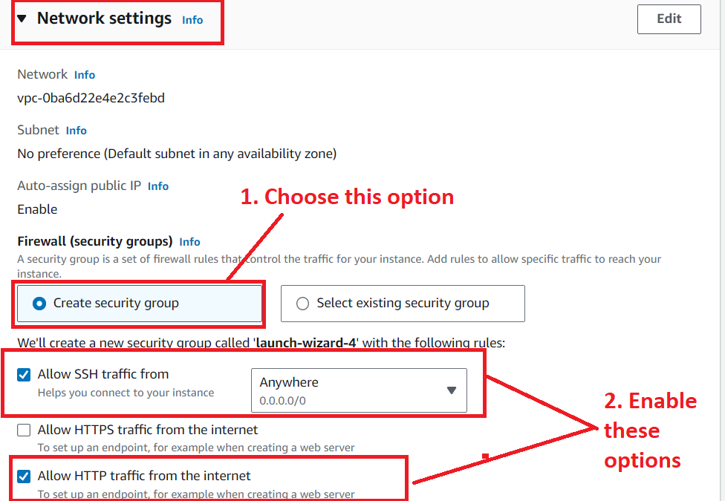

**(B). Click** on the **“Edit”** in the **“Network Settings”.**

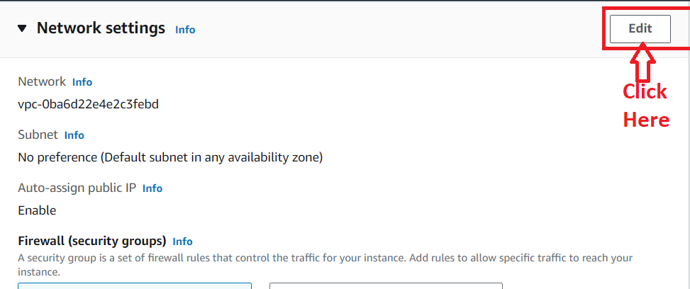

**(C). Rename** the **“Security Group” & “Description”** as **“Task1-Apache2-Case-Study”.**

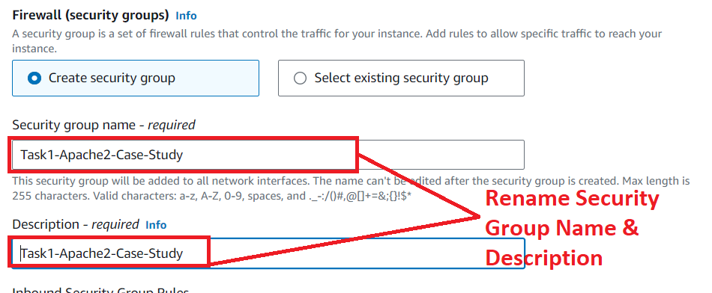

**Step 9: Leave** the **“Configure Storage”** as **it is** & **click** onthe **“Launch Instance”.**

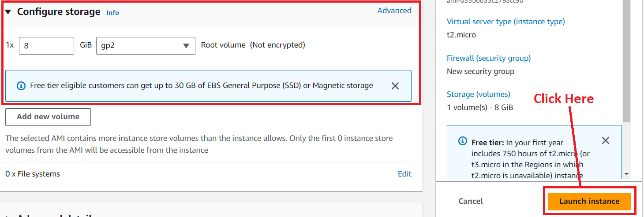

**Step 10: The instance** will be **launched successfully. Click** on this **hyperlink:** [**i-037d7faca13ba1a95**](https://us-east-1.console.aws.amazon.com/ec2/home?region=us-east-1#Instances:instanceId=i-037d7faca13ba1a95)

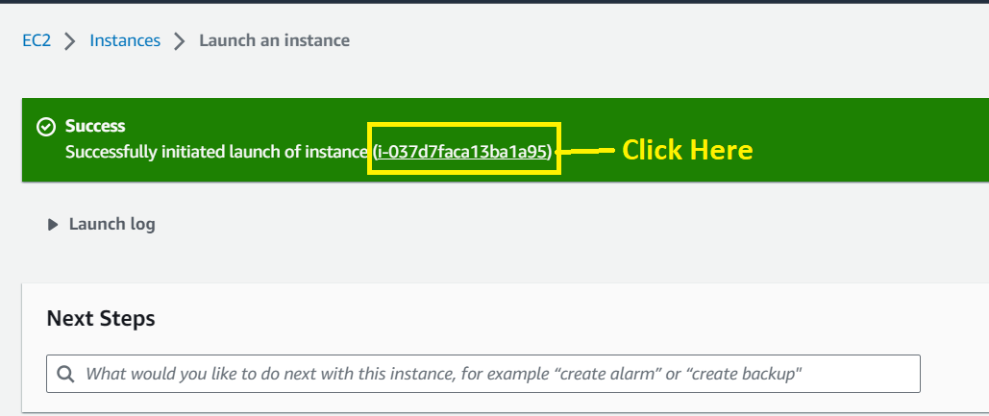

**Step 11: Your instance** will be **in** the **“Running” state.**

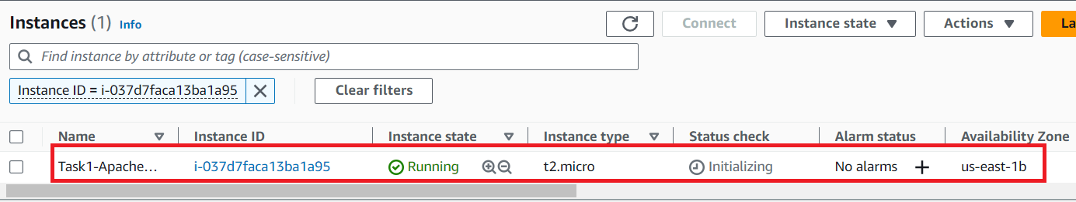

**Step 12: Now, we** will **connect** our **machine using** the **"EC2 Instance Connect". Select** the **Instance ["Task1-Apache2-Case-Study"]** & **click** on the **"Connect".**

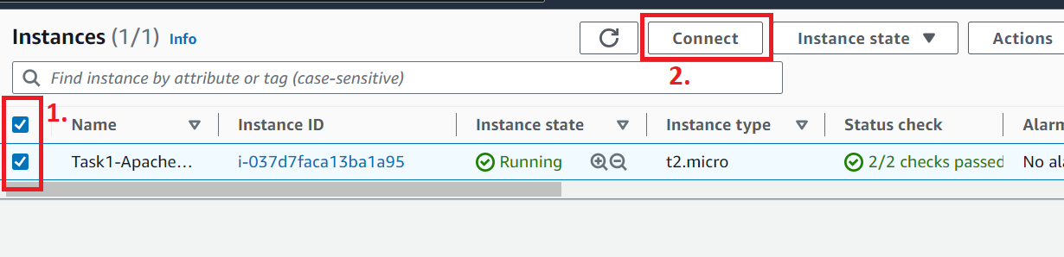

**Step 13: Again, click** onthe **“Connect”.**

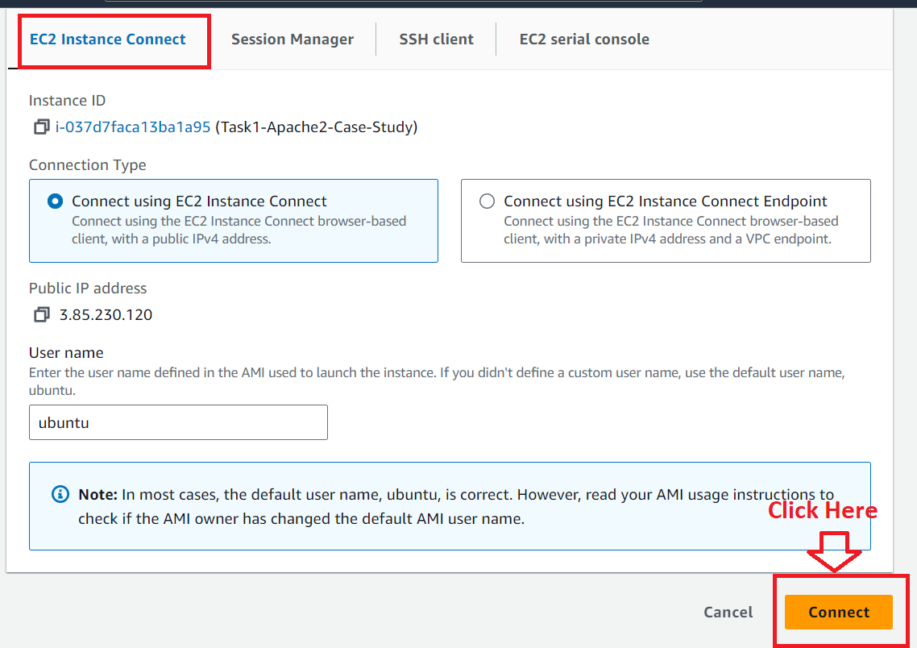

**Step 14: The instance [Task1-Apache2-Case-Study]** will be **successfully connected.**

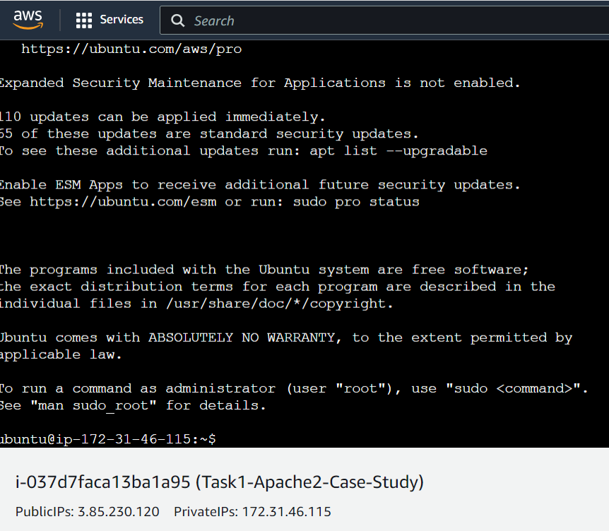

**Step 15: First, we** will **update** the **instance [Task1-Apache2-Case-Study]** for a **smooth running using** the **below-given command:**

**First Command: sudo apt-get update**

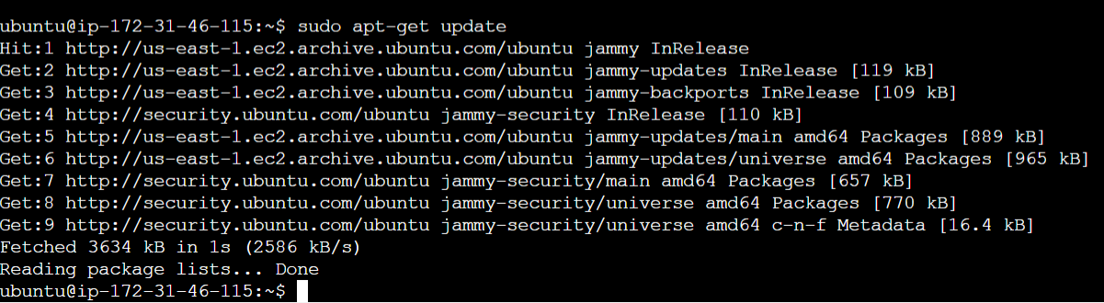

**Step 16: Now, we** will **install** the **Apache server over** this **instance using** the **below-given command:**

**sudo apt-get install apache2 -y**

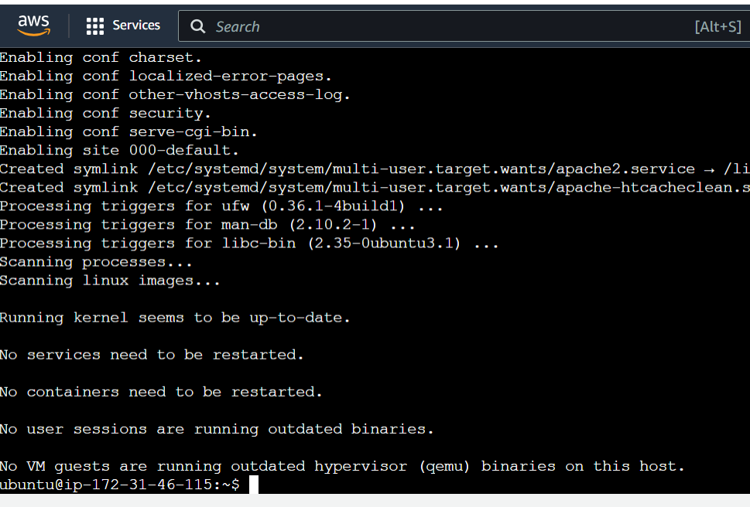

**Step 17: Now, the apache server** will be **successfully installed** on **the “Task1-Apache2-Case-Study” instance** or **not** by **pasting** the **public IP address** in the **browser bar.**

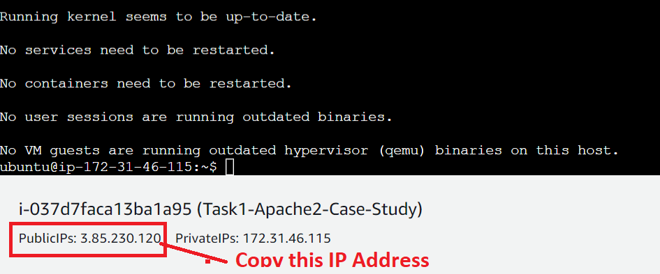

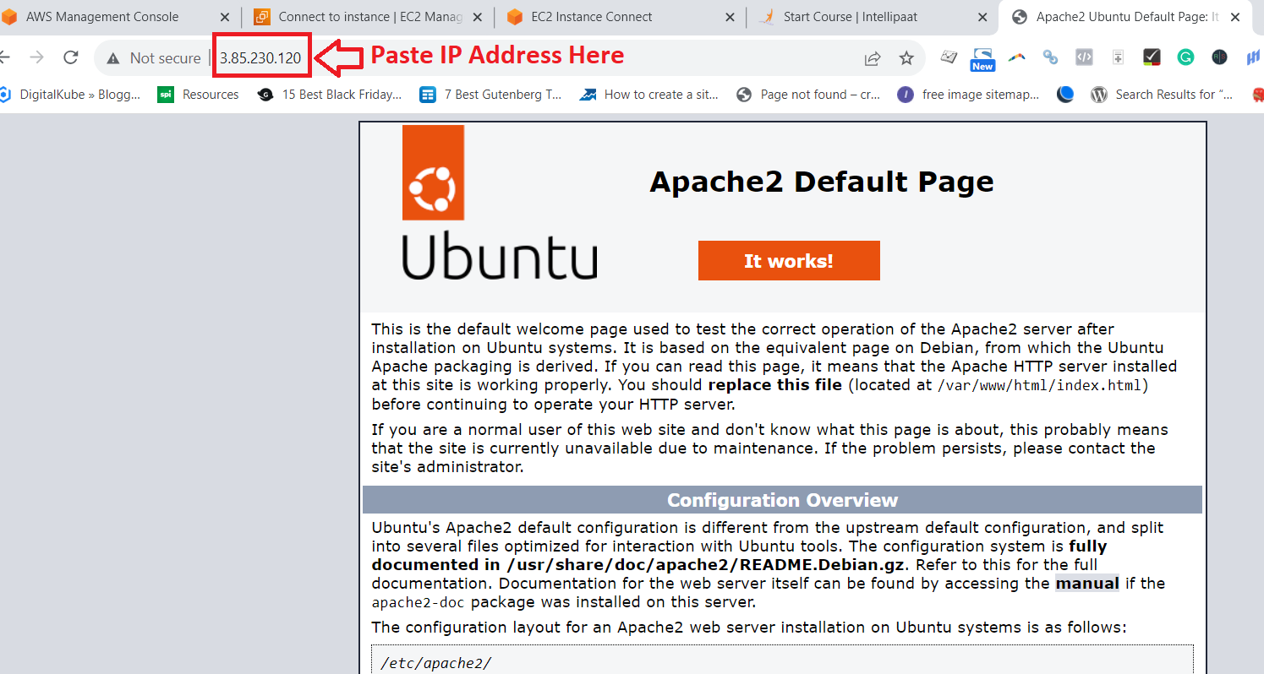

**The "Apache2"** will be **successfully installed** on the **"Task1-Apach2-Case-Study"** machine.

**Step 18: Now, we** will **change** the **directory** to **access** the **html using** the **below-given** command:

**cd /var/www/html**

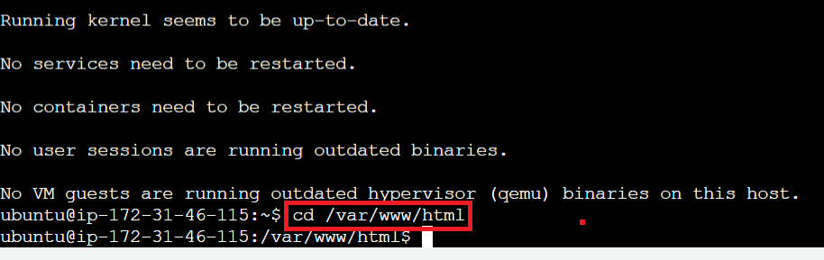

**Step 19: Now, we** will **run** the **below-given command** to **check** the **index.html** is **present** or **not:**

**ls**

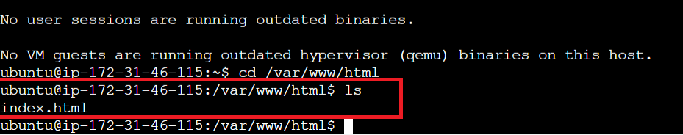

**The index.html** is **present.**

**Step 20: Now, we** will **add some content** in the **index.html file using** the **below-given command:**

**echo “Hello, World” >index.html**

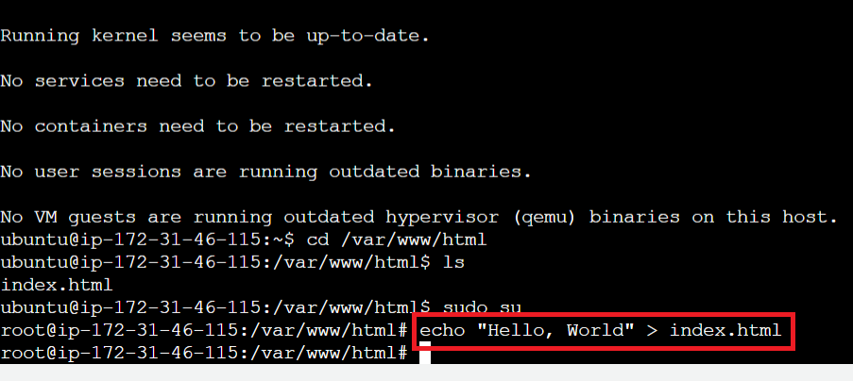

**Step 21: The content** will be **successfully added. Check** the **added content using** the **below-given command:**

**cat index.html**

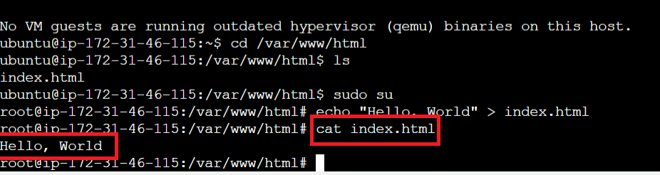

**Also, refresh** the **public IP address** inthe **browser.**

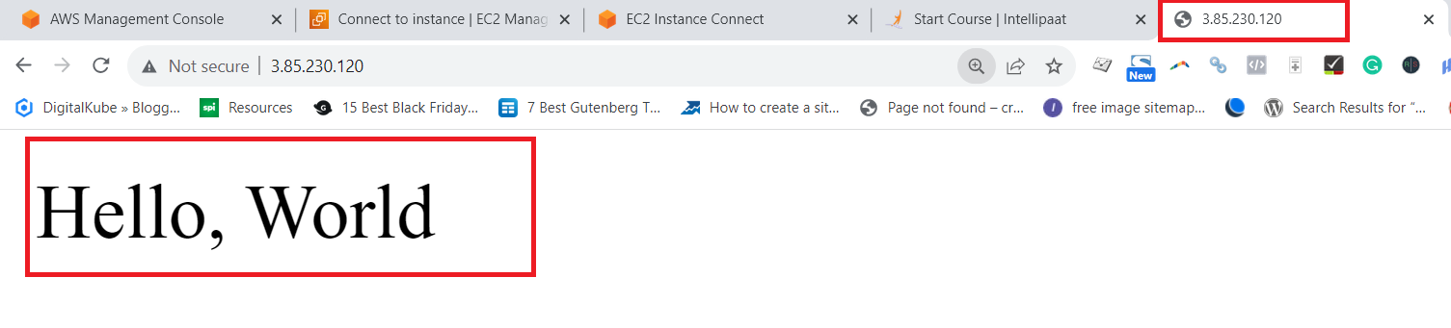

**Problem 2 Solution:** Replicate the instance in us-west-2 (Oregon) region

For replicating the instance, first, we have to create an AMI image. After creating the AMI image, we enable to replicate the instance in another region.

**A. Create an AMI Image**

**Step 1: Go** tothe **“Instances (running)”** section.

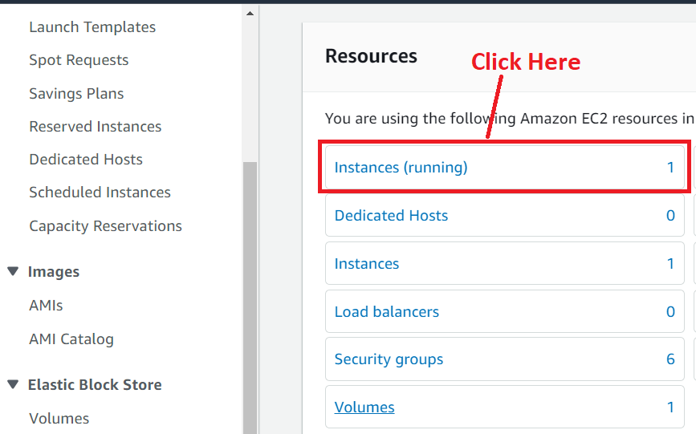

**Step 2: Select the "Task1-Apache2-Case-Study" Instance. Go** to the **"Actions>Image and Templates>Create image".**

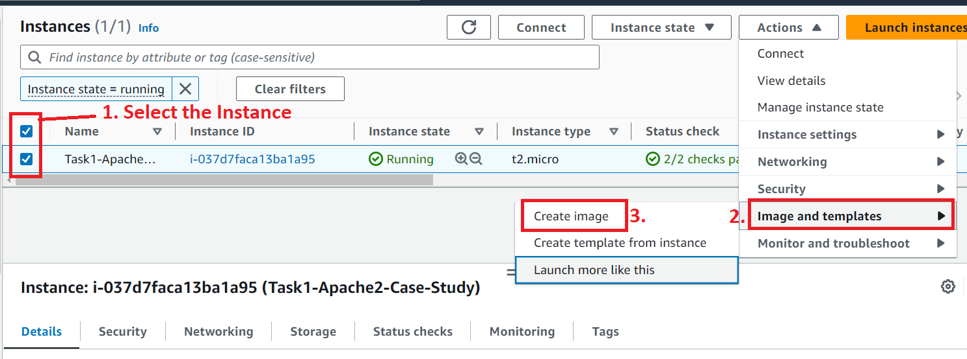

**Step 3: Choose the “Image Name** & **Image Description”** as **“Task1-Apache2-Case-Study-AMI”.**

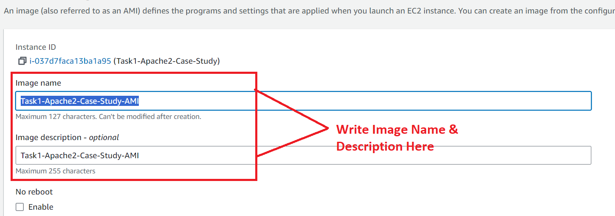

**Step 4: The “EBS volume** will be **remained same. No need** to **change here.**

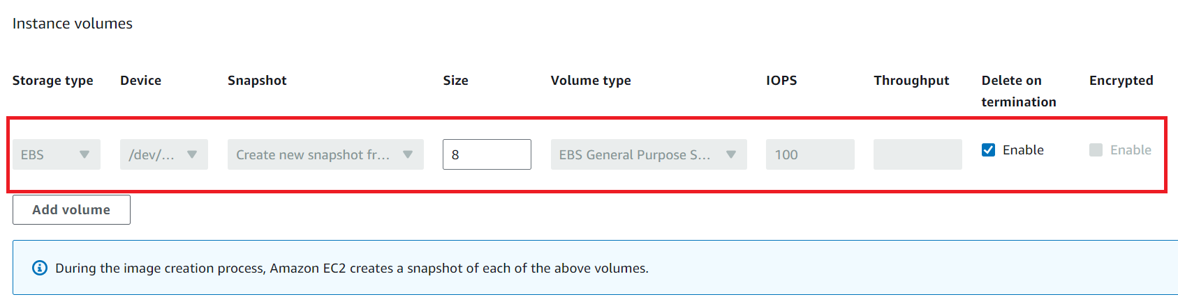

**Step 5: In** the **“Tags”** section**, choose** the **“Tag Image and snapshots together”** option. **While choose** the **“Key”** as **“Name” &** the **“Value-optional”** asthe **“Task1-Apache2-Case-Study-AMI”. Click** onthe **“Create”.**

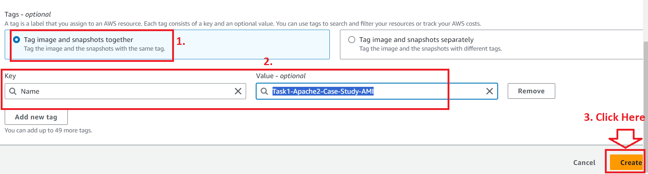

**Step 6: Now, your AMI** will be **in the “Created state”. Click** onthe **hyperlink** in the **green colour.**

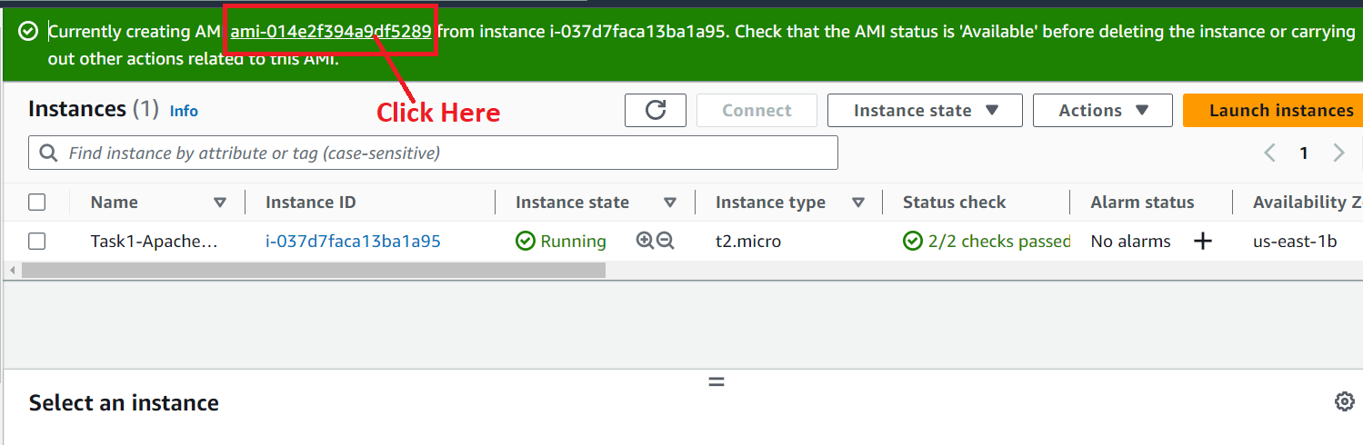

**Step 7: You** will be **redirected** tothe **“AMI” page & the “AMI status”** will be **shown** as **“Pending”.**

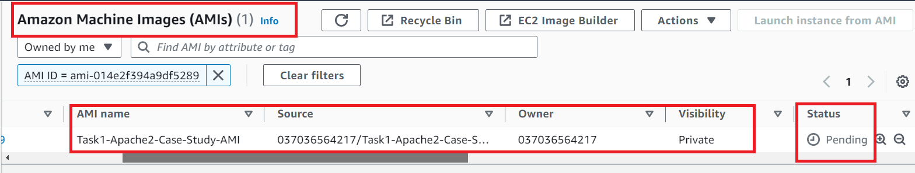

**Step 8: The AMI** will **take some time** to **available** & **shown** the **status** as **“Available”** after **few minutes.**

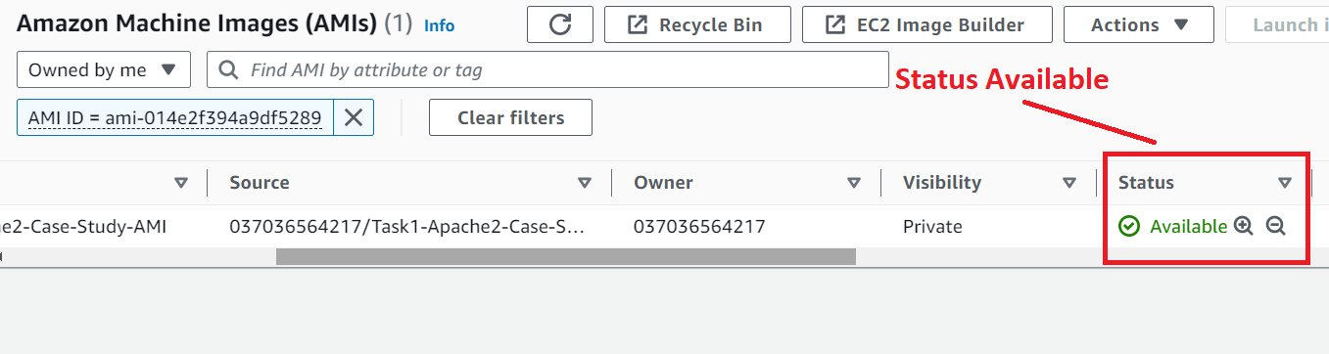

**B. Copy Amazon Machine Image (AMI) to the Oregon Region**

**Step 1: Select** the **AMI. Go** tothe **“Actions>Copy AMI”.**

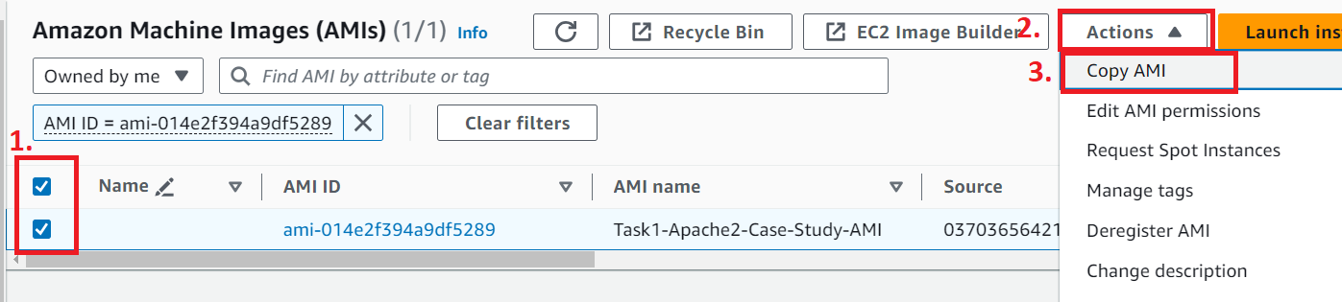

**Step 2: Choose** the **“Destination Region”** as the **“US West (Oregon)”.**

**Enable** the **“Copy Tags” option** also.

**Click** on the **“Copy AMI”.**

**c**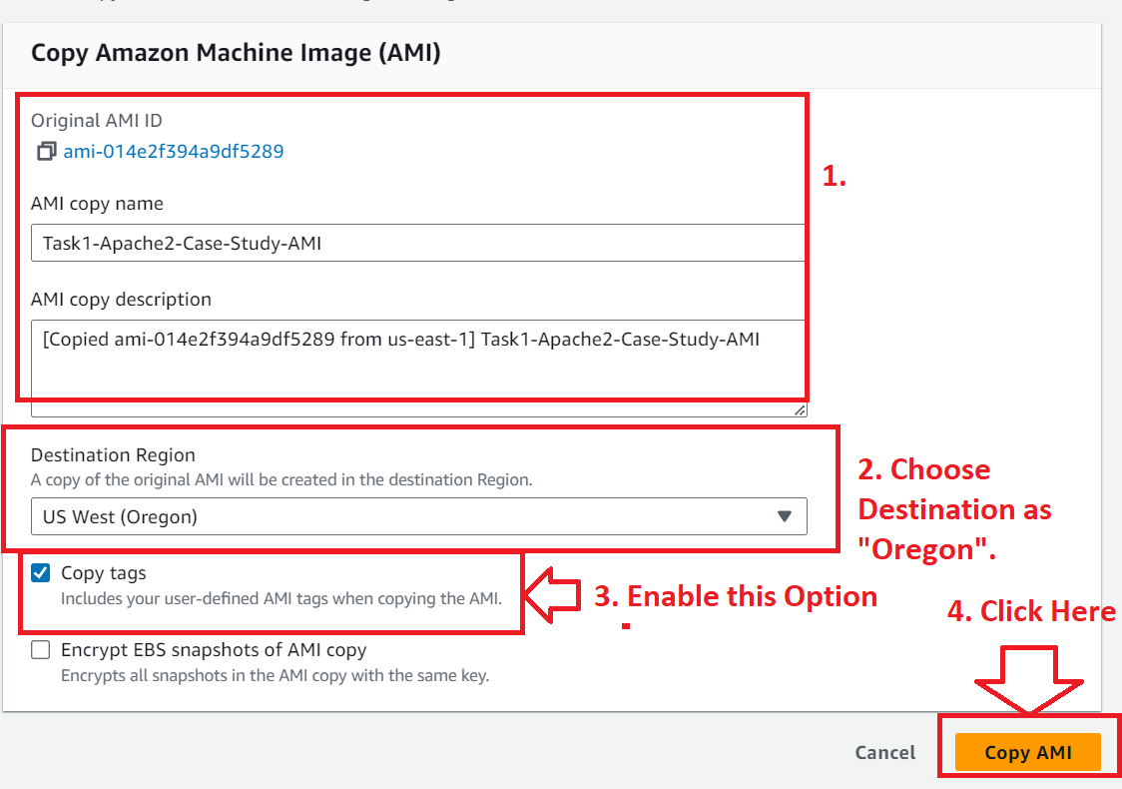

**Step 3: The “AMI copy”** will be **initiated** to **the “Oregon” region. Click** onthe **“us-west-2”.**

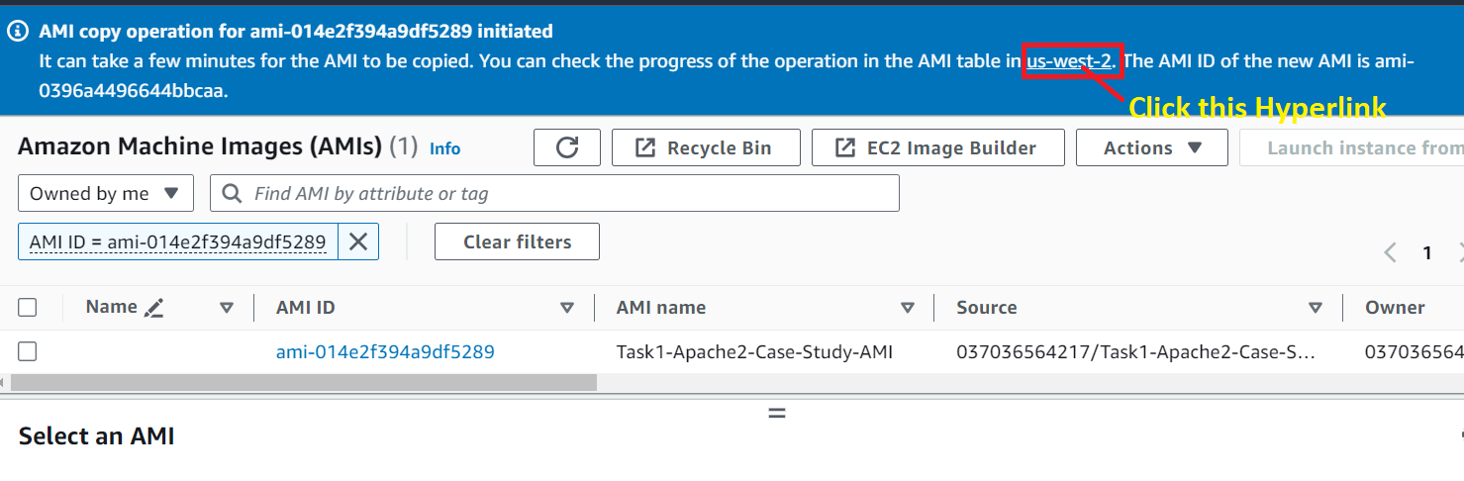

**Step 4: The “AMI status”** is **shown** as **“Pending”** in the **“Oregon” region.**

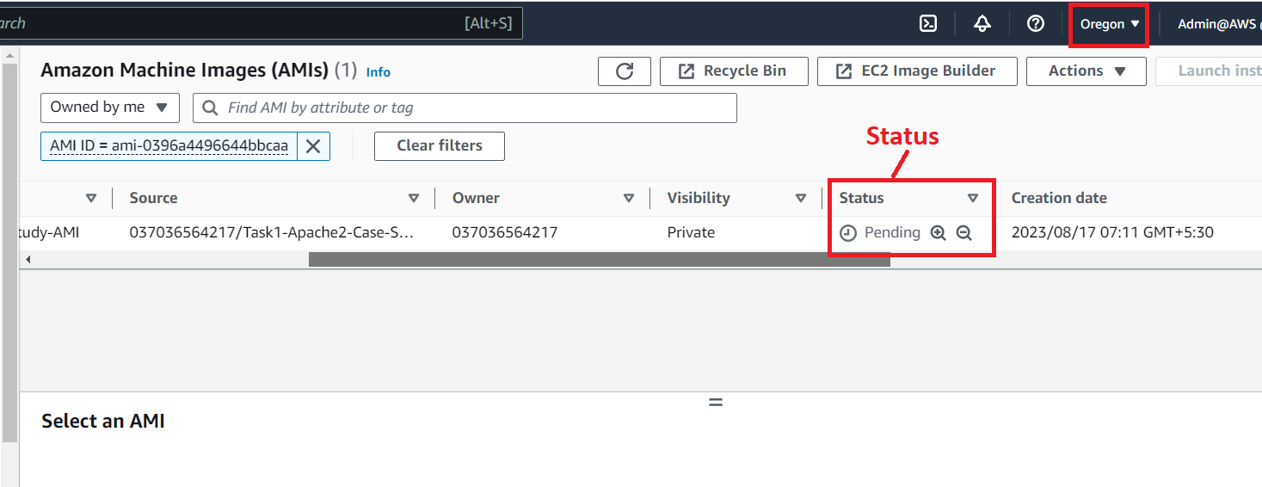

**Step 5: Now,** the **AMI Status** inthe **“Oregon” region** shown as **“Available”.**

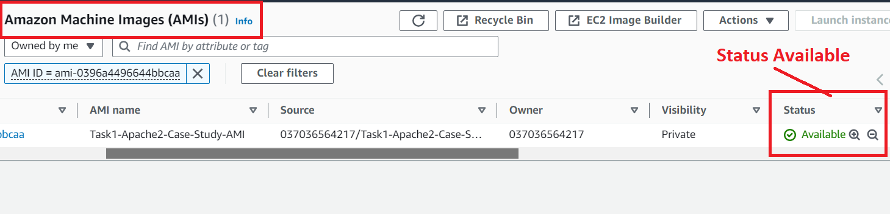

**So the “AMI (Amazon Machine Image)”** has been **successfully copied** to the **“Oregon”** region**.**

**C. Launch the Instance from the Above Created AMI**

**Step 1: Select** the **AMI** & **click** on the **“Launch Instance from AMI”.**

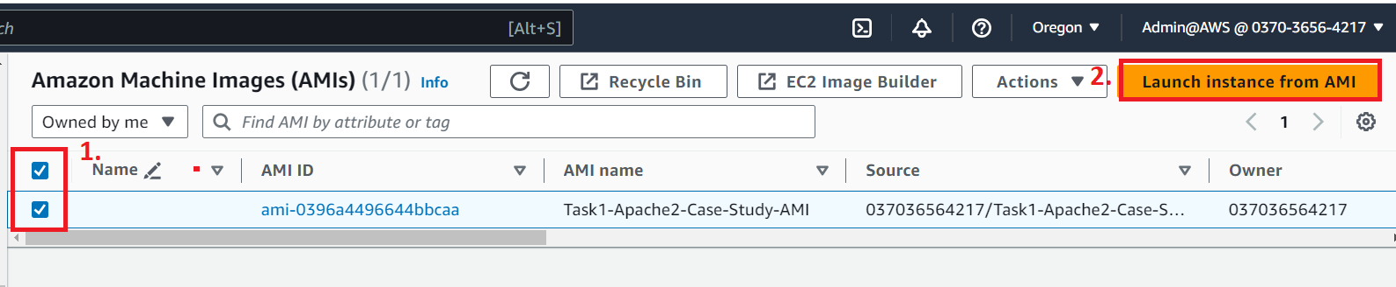

**Step 2: Choose** the **name** as **“Task-02-Case-Study-Oregon”.**

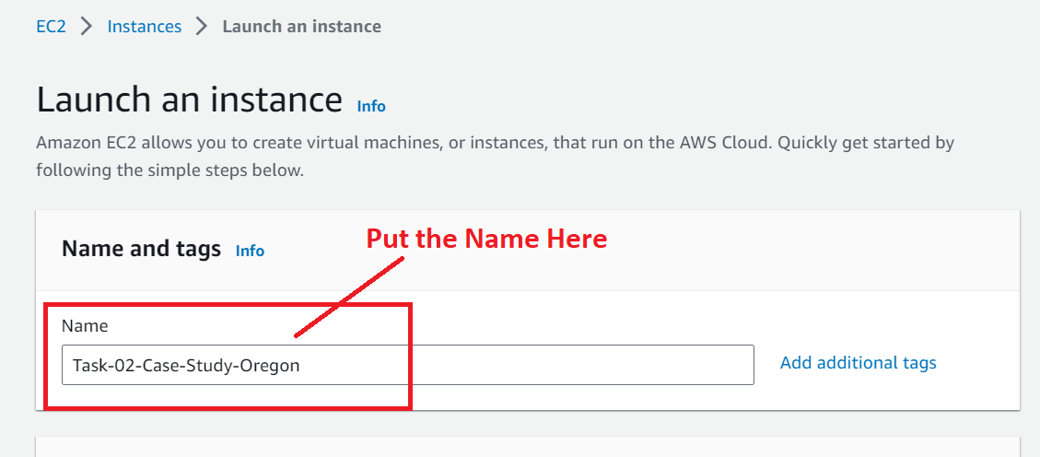

**Step 3: The “Copied AMI”** will be **shown** in the **“Application and OS Images (Amazon Machine Image)”** section.

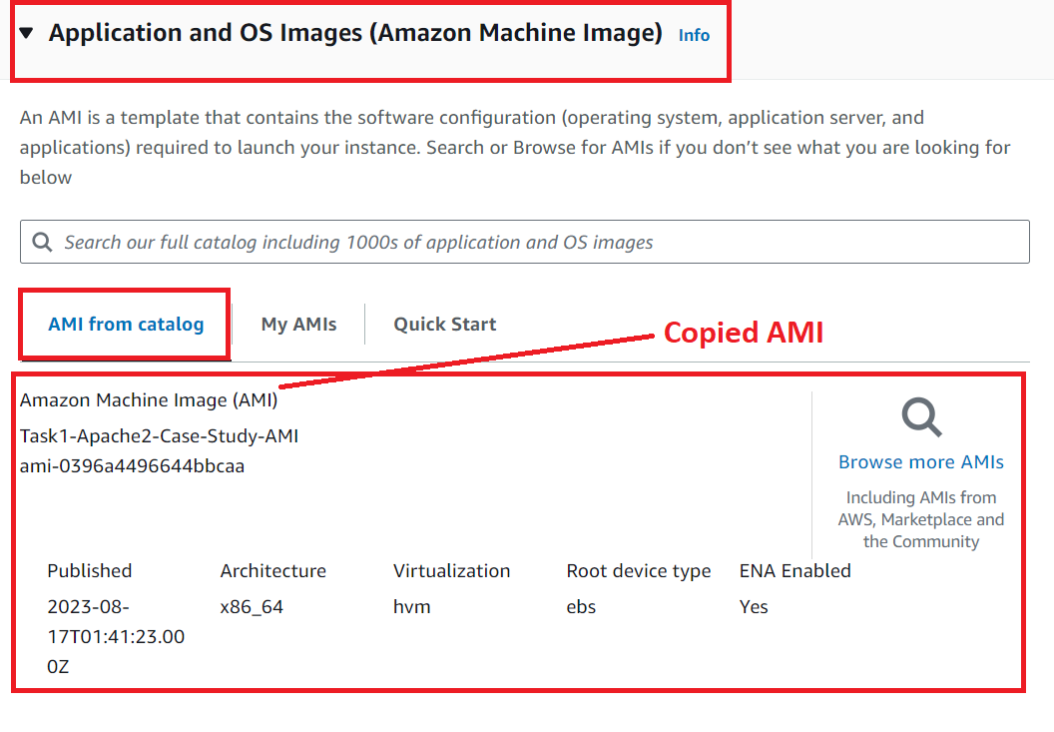

**Step 4: Choose** the **“Instance Type”** as **“t2.micro”.**



**Step 5: In** the **“Key pair (login)”, choose** the **“Proceed without a key pair (Not recommended)”** option.

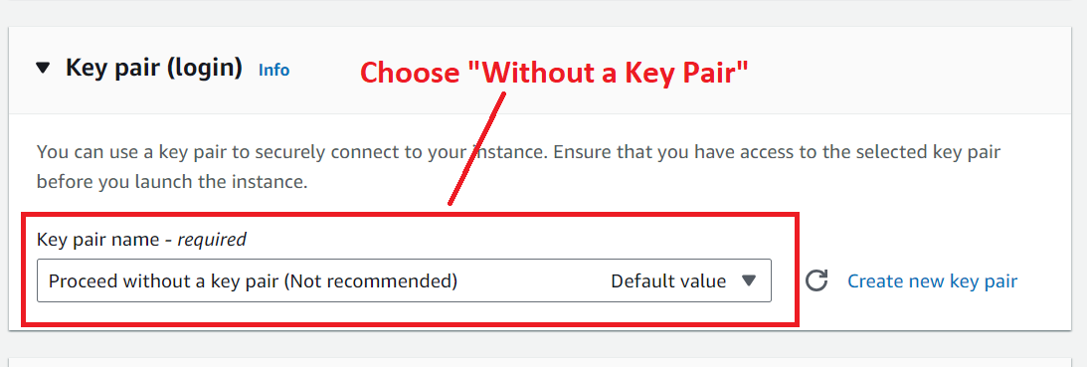

**Step 6: Enable** the **“Allow HTTP traffic from the internet”** in the **“Network Settings”.**

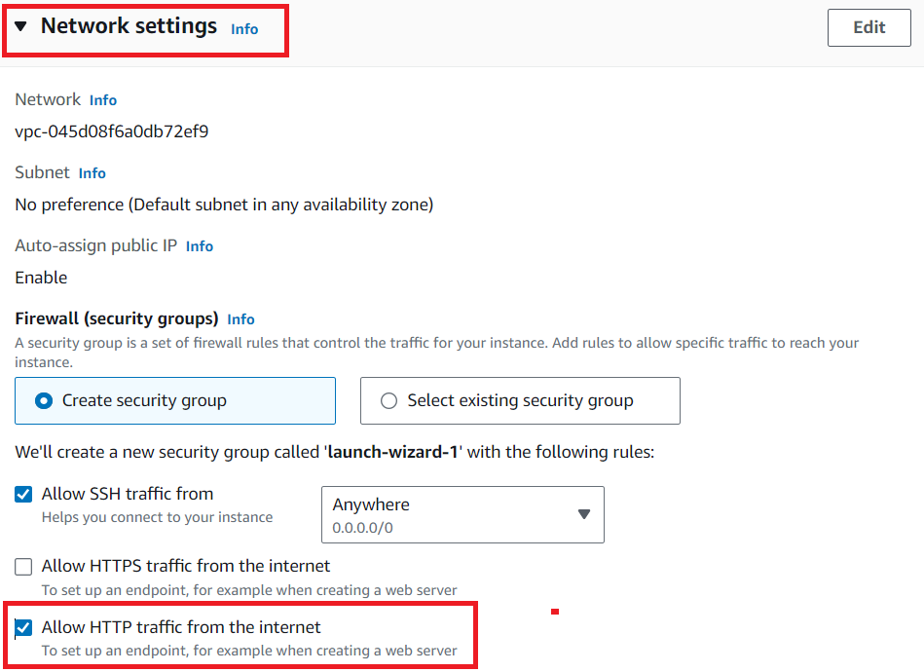

**Step 7: Leave** the **“Root EBS Volume”** as **it is. Click** on **“Launch Instance”.**

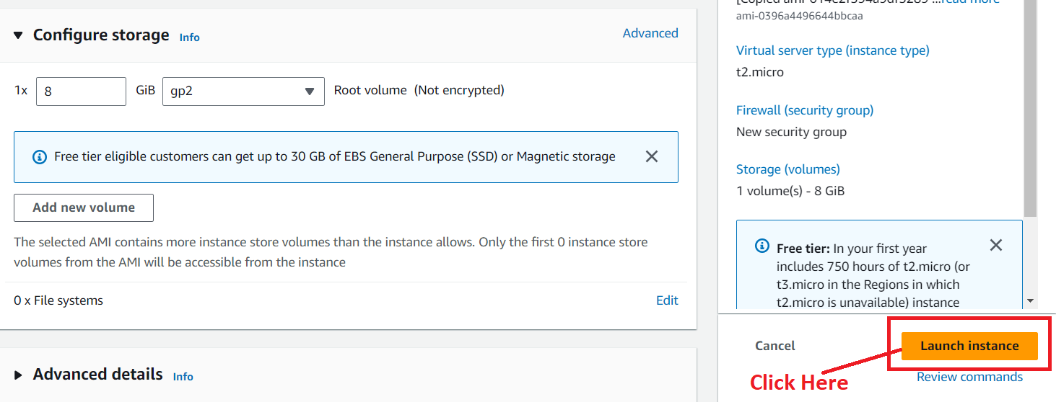

**Step 8: The Instance** will be **launched successfully. Click** on the **hyperlink (**[**i-066df1a1c3fb50128**](https://us-west-2.console.aws.amazon.com/ec2/home?region=us-west-2#Instances:instanceId=i-066df1a1c3fb50128)**).**

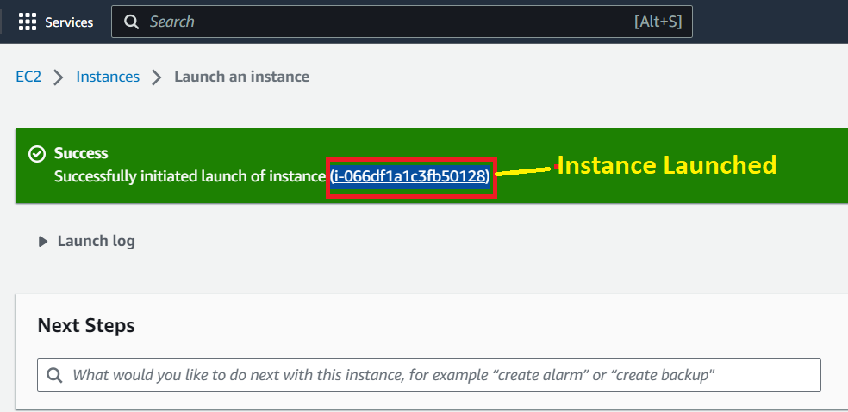

**Step 9: The “Instance (Task-02-Case-Study-Oregon)”** will be **in** the **“Running” State.**

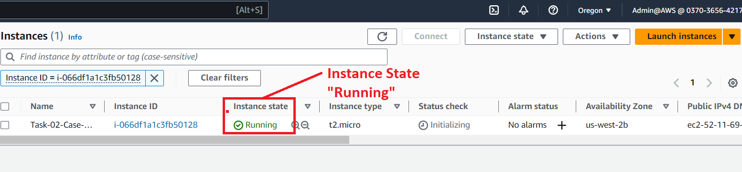

**Step 10: Now, copy** the **public IP Address (52.11.69.129)** of the **available instance** in the **“Oregon” Region.**

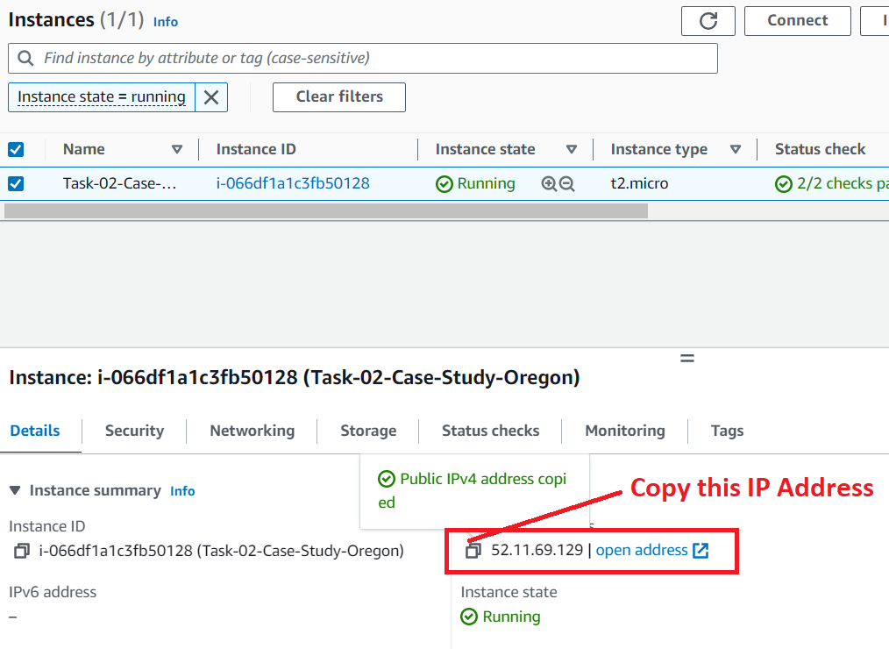

**Step 11: Now, paste** the **Public IP Address** in the **browser address bar** & **the same page** will be **shown** as **the “North Virginia” region.**

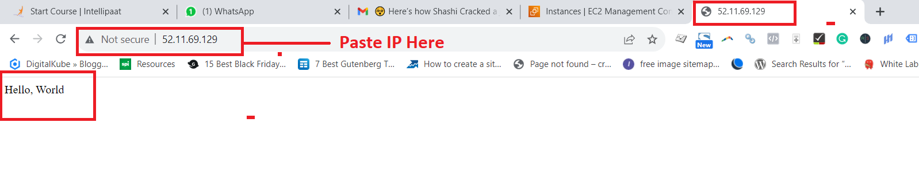

**This means, the instance** is **successfully replicated** to the **“Oregon” Region.**

**Problem 3 Solution:** Build two EBS volumes and attach them to the instance in the us-east-1 (N. Virginia) region

**A. Create the First Volume (EBS-Volume-1)**

**Step 1: Go** tothe **“Elastic Block Store>Volumes”.**

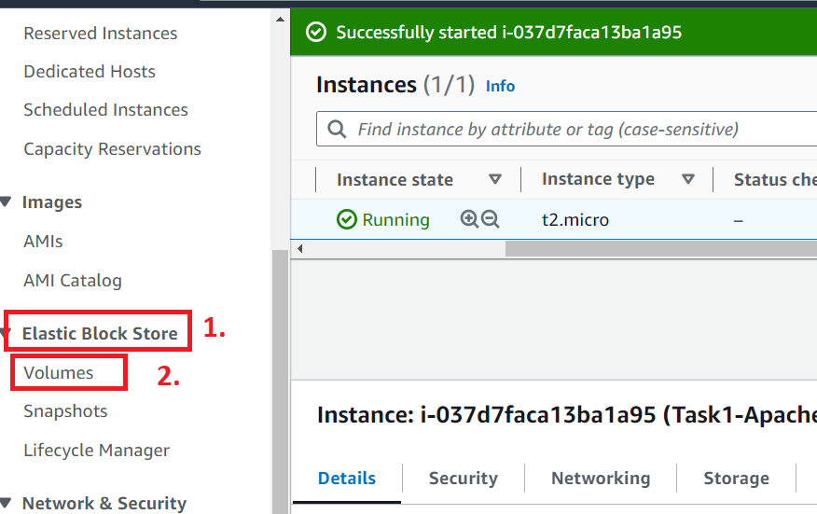

**Step 2: Click** onthe **“Create Volume”. Create** an **EBS volume** in that **availability Zone, Where EC2 Instance** is **running. Ours** is **running** in the **“us-east-1b”.**

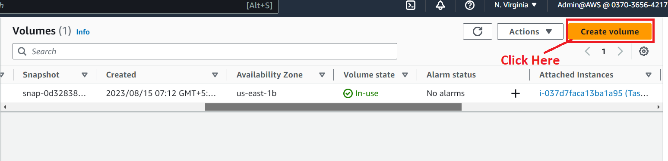

**Step 3: Choose** the **“Volume Size” &** the **“Availability Zone”** here**.**

**Size –** 1 GiB

**Availability Zone –** us-east-1b

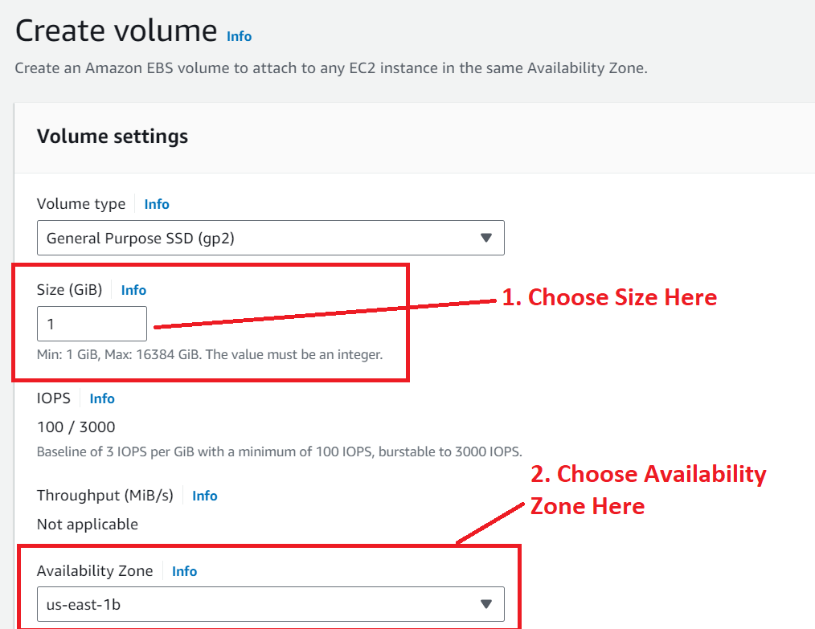

**Step 4: Click** onthe **“Add tag”.**

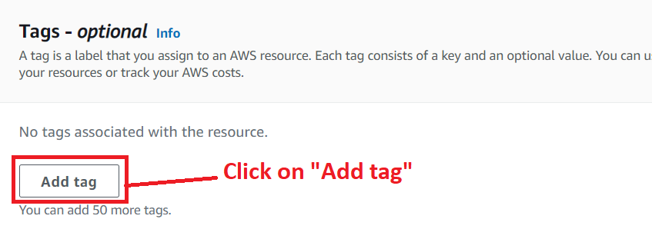

**Step 5: Choose** the **following parameters** inthe **“Tags-optional”.**

**Key:** Name

**Value- optional: EBS-Volume-1**

**Click** onthe **“Create volume”.**

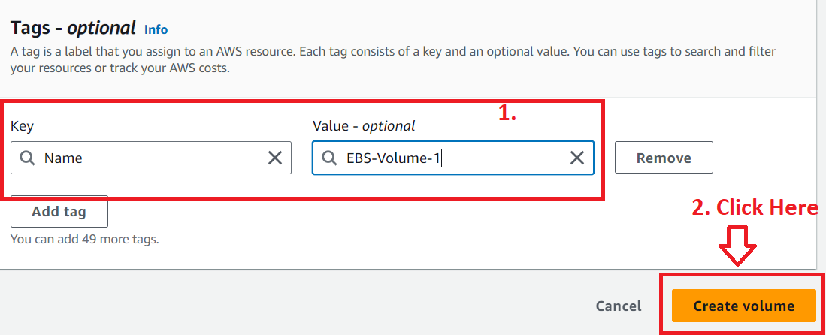

**Step 6: Your EBS Volume** has been **successfully created.**

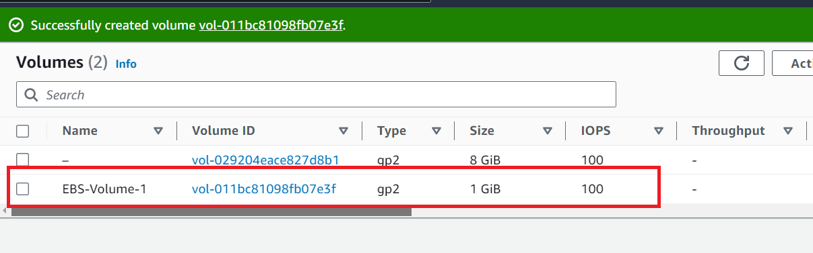

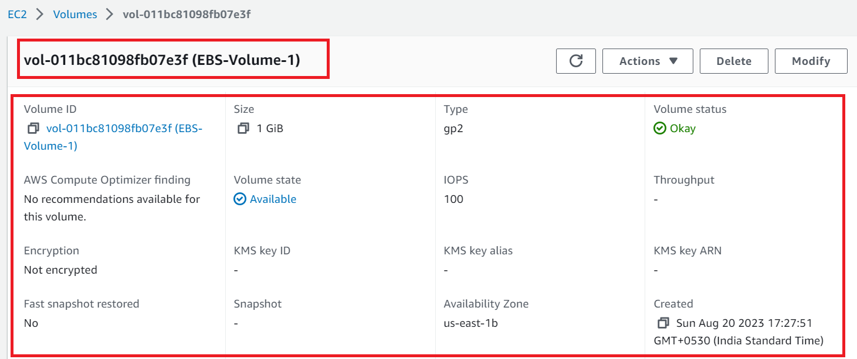

**B. Create the Second Volume (EBS-Volume-2)**

**Step 1: Go** tothe **“Elastic Block Store>Volumes”.**



**Step 2: Click** onthe **“Create Volume”. Create** the **EBS** in that **availability Zone, Where** the **EC2 Instance** is **running. Ours** is **running** in **“us-east-1b”.**



**Step 3: Choose** the **“Volume size** & the **“Availability Zone”** here**.**

**Size –** 1 GiB

**Availability Zone –** us-east-1b

**s**

**Step 4: Click** onthe **“Add tag”.**



**Step 5: Choose** the **following parameters** in **“Tags-optional”.**

**Key:** Name

**Value- optional:** EBS-Volume-2

**Click** onthe **“Create volume”.**

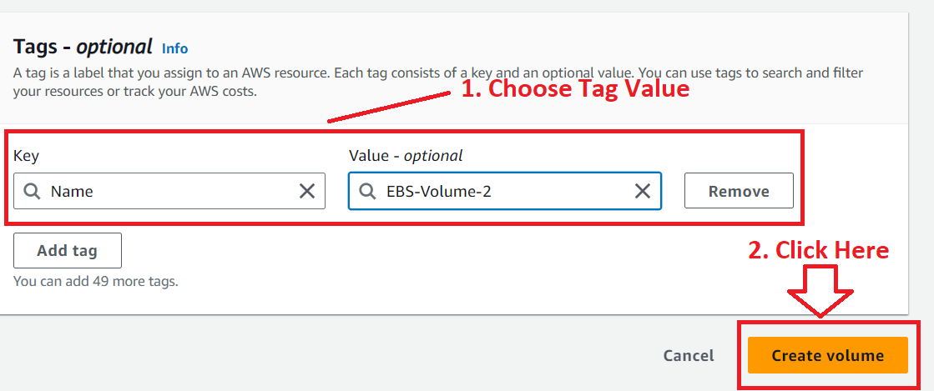

**Step 6: The "EBS-Volume-2" has been successfully created.**

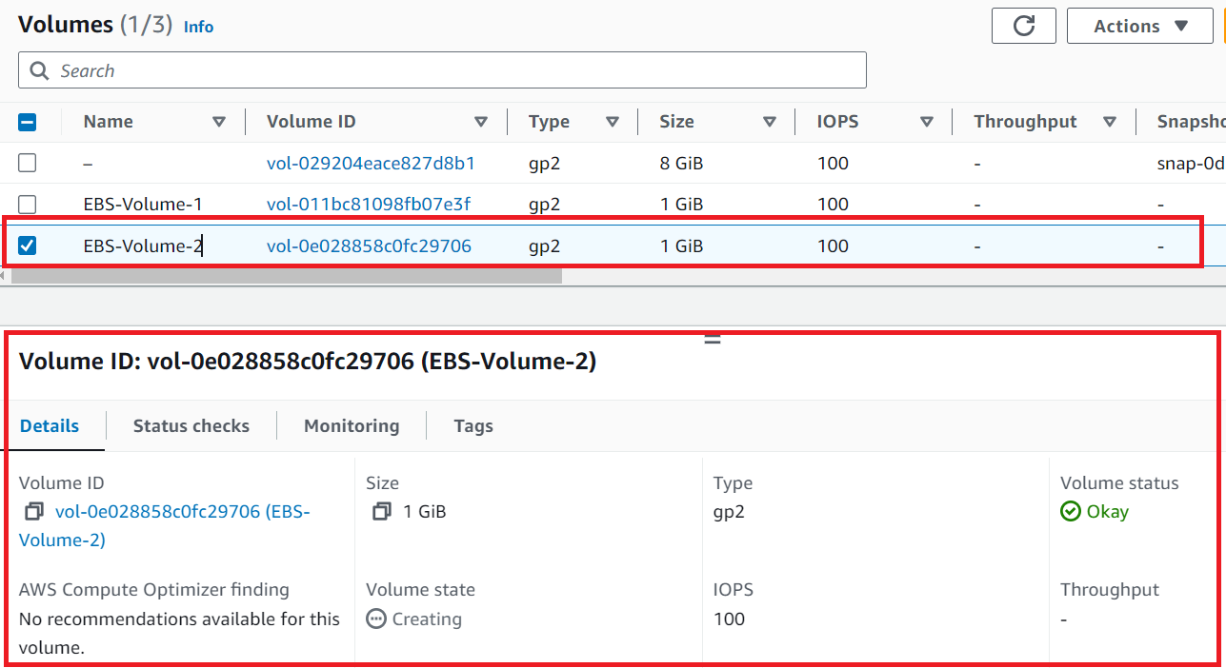

**So, the two EBS Volumes** have been **successfully created** in the “**us-east-1 (North Virginia)”** Region**.**

**C. Attach the First EBS Volume [EBS-Volume-1] to the EC2 Instance [Task1-Apache2-Case-Study]**

**Step 1: Select** the **“first volume (EBS-Volume-1). Go** tothe **“Actions>Attach Volume”.**

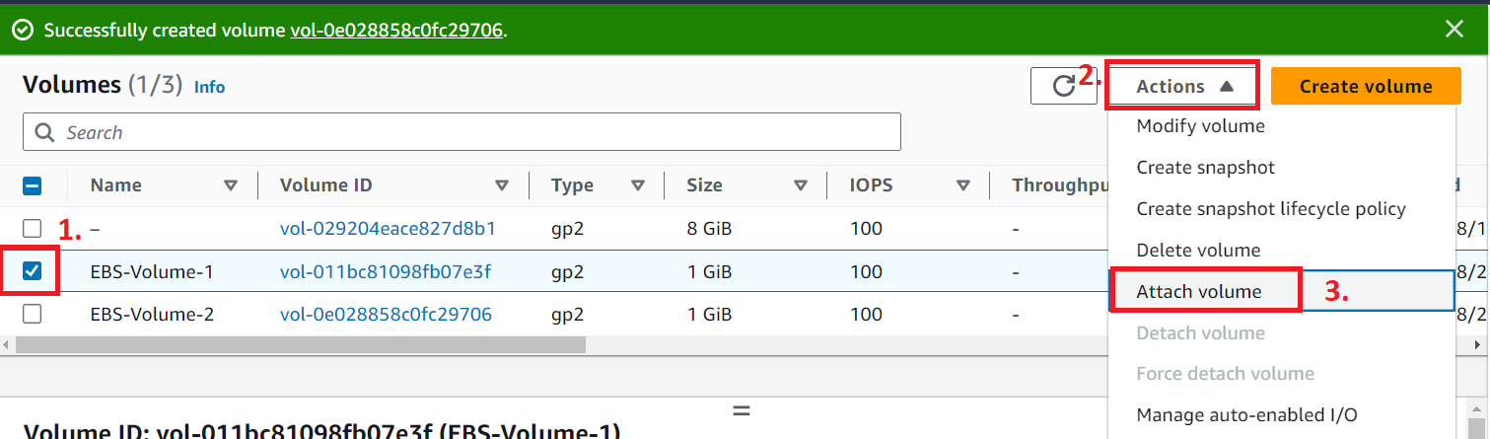

**Step 2: Select** your **Instance. We** have **one instance [Task1-Apache2-Case-Study] available, which** is **showing. Click** on the **“Attach Volume”.**

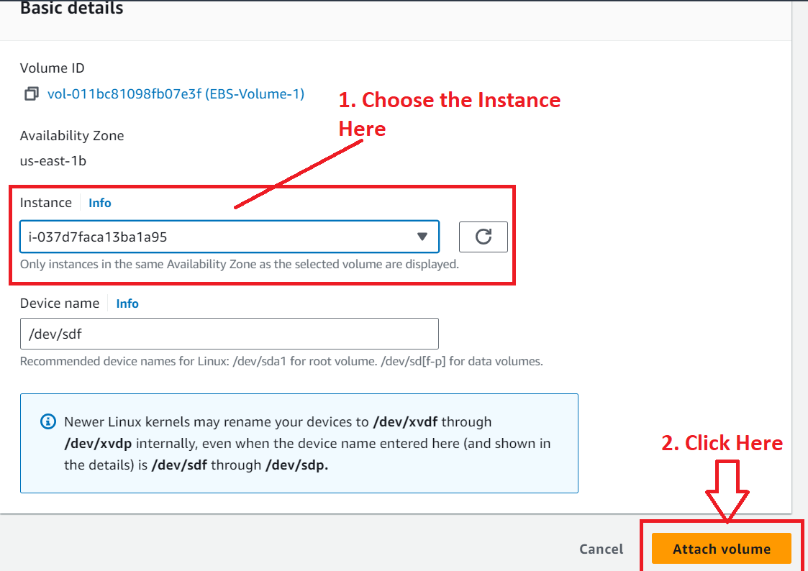

**Step 3:** The **"EBS-Volume-1"** has been **successfully attached** to the **“EC2 Instance [Task1-Apache2-Case-Study]”** available in **the "North Virginia" region.**

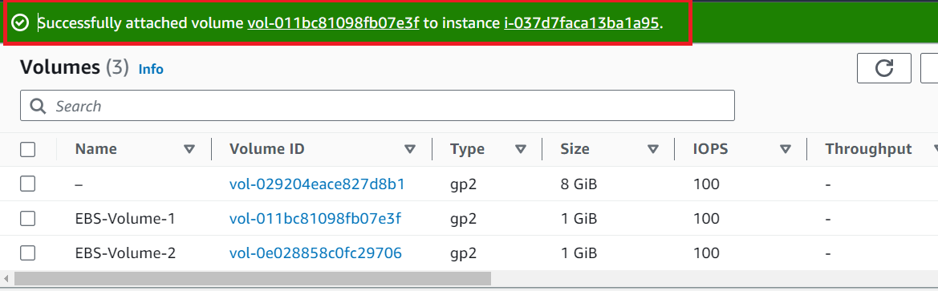

***The first volume*** *has been* ***successfully attached*** *to the* ***EC2 Instance. Now, we*** *will* ***attach*** *the* ***second volume (EBS-Volume-2)*** *to**the* ***EC2 Instance [Task1-Apache2-Case-Study].***

**D. Attach the Second EBS Volume [EBS-Volume-2] to the EC2 Instance [Task1-Apache2-Case-Study]**

**Step 1: Choose** the **second volume (EBS-Volume-2). Go** to the **“Actions>Attach Volume”.**

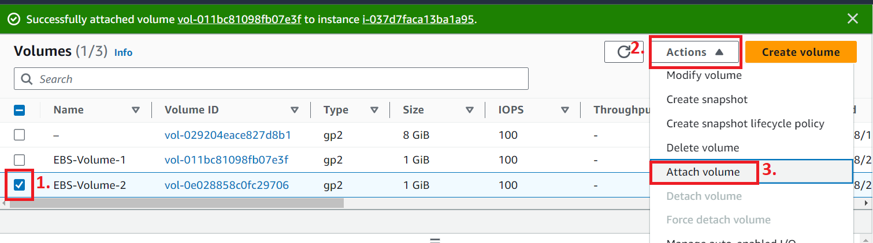

**Step 2: Choose** the **Instance [Task1-Apache2-Case-Study]. We** have **only one instance available, which** is **showing. Click** on the **“Attach Volume”.**



**Step 3:** The **“EBS-Volume-2”** has been **successfully attached** to **the EC2 Instance [Task1-Apache2-Case-Study] available** inthe **“North Virginia” region.**

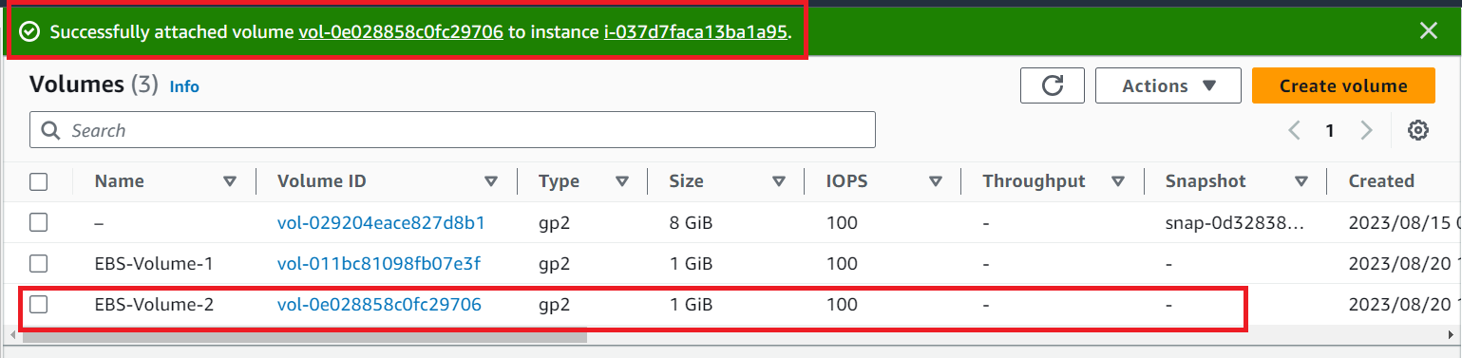

The **second volume** has been **successfully attached** to the **EC2 Instance.**

**Problem 4 Solution:** Delete one volume after detaching it and extend the size of other volume.

**A. Detach & Delete the Volume from EC2 Instance**

**Step 1: First, we** will **select** the **second volume** for **deletion. Go** to the **“Volume>Actions>Detach Volume”.**

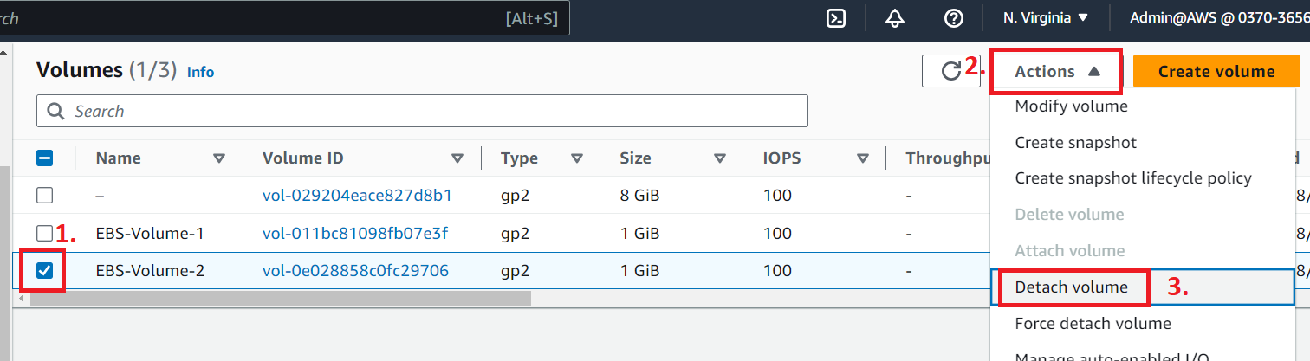

**Step 2: Click** on the **“Detach”.**

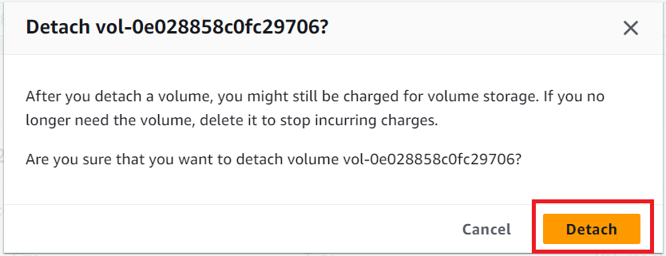

**Step 3:** The **“EBS-Volume-2”** will be **successfully detached.**



**Step 4: Select** the **“Volume>Actions>Delete volume”.**

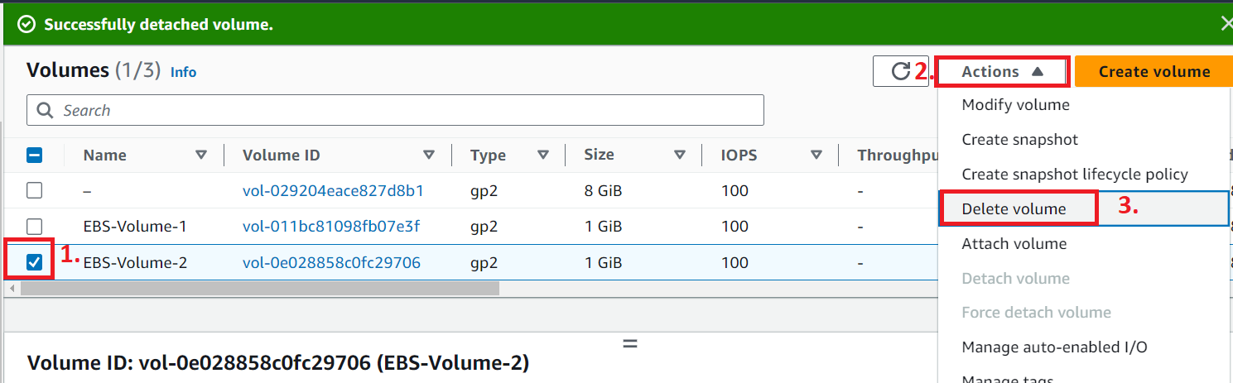

**Step 5: Click** onthe **“Delete”.**

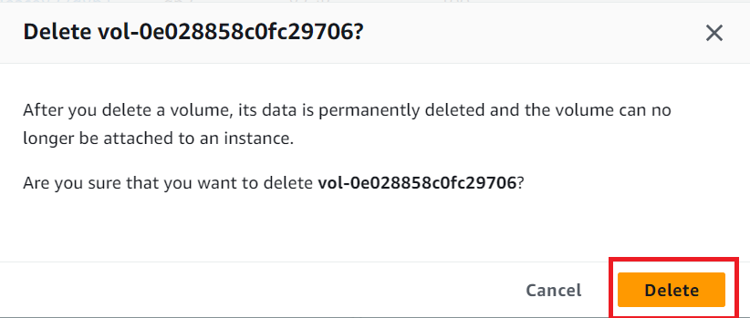

**Step 6: The “EBS-Volume-2”** has been **successfully deleted.**

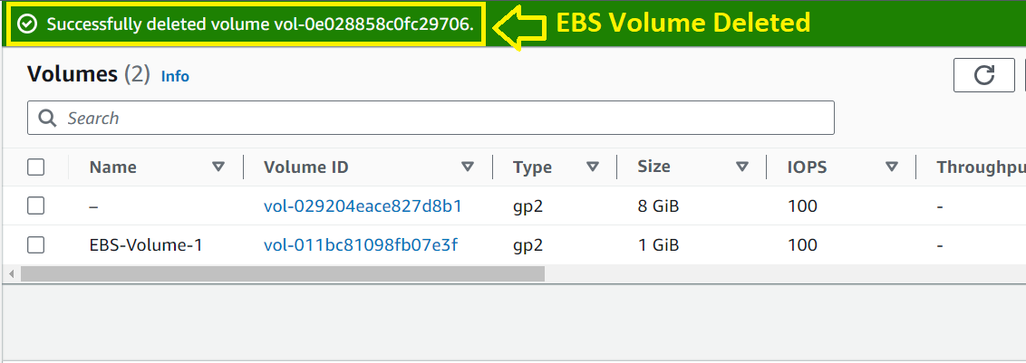

**B. Extend the Size of Other Volume (EBS-Volume-1)**

**Step 1: Select** the **“Volume>Actions>Modify volume”.**

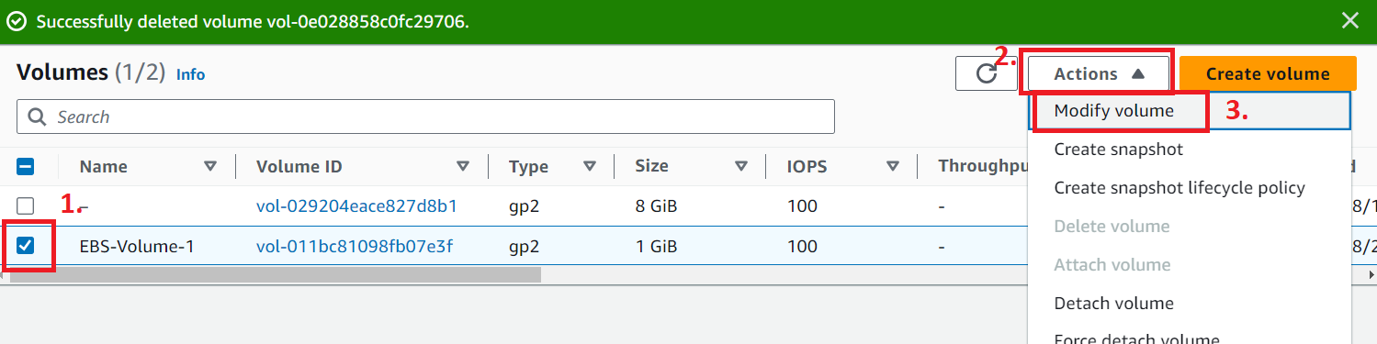

**Step 2: Increase** the **Size** from **1 GiB** to **2 GiB. Click** onthe **“Modify”.**

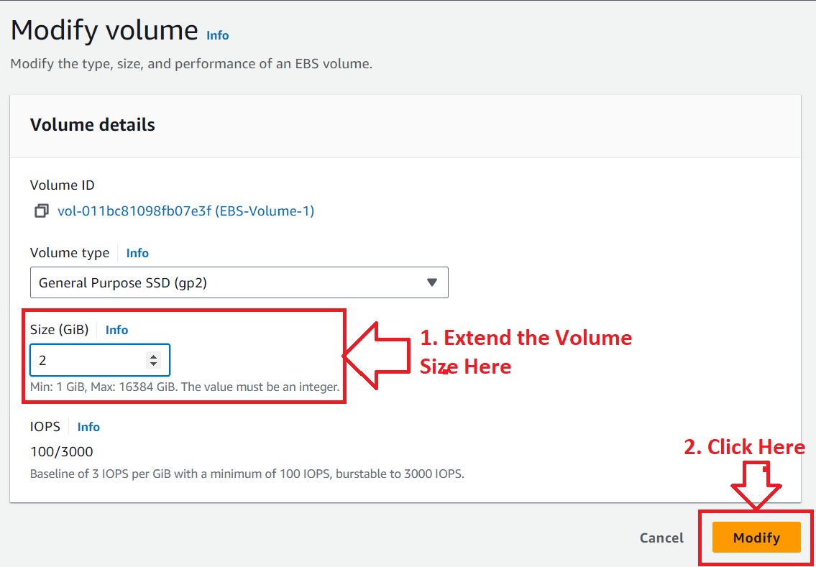

**Step 3: Click** onthe **“Modify”.**

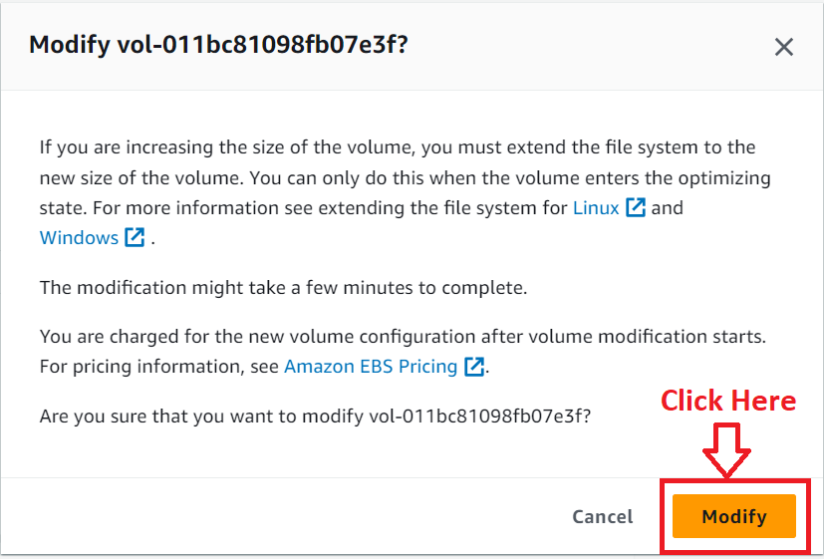

**Step 4: The “EBS-Volume-1”** has been **successfully modified.**

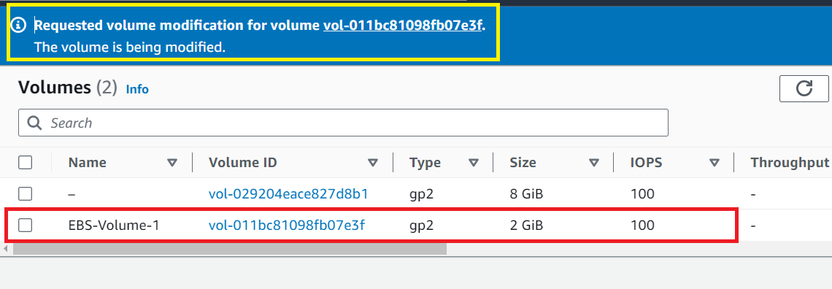

**Step 5: You** can **view** your **volume size extension** inthe **EC2 Instance [Task1-Apache2-EC2-Case-Study] configuration** also**. Select** your **EC2 Instance** & **Go** to **the “Volume” section. Your volume sizes** will be **shown.**

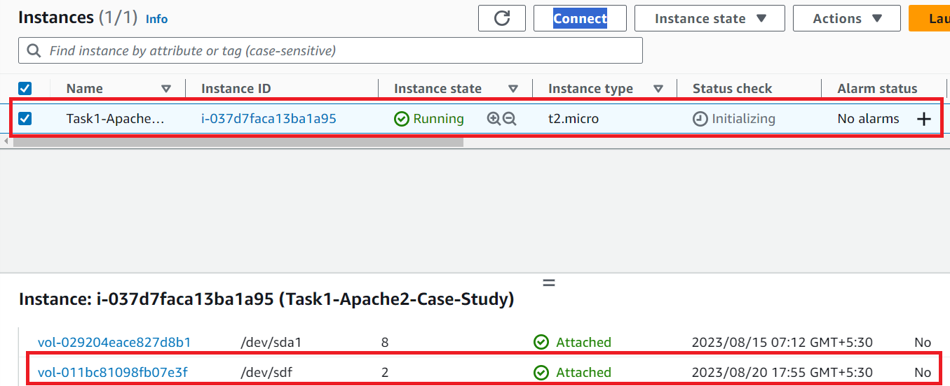

**Problem 5 Solution:** Take the Back-up of EBS Volume

**Step 1: If you want to create the backup of EBS Volume, you must create the snapshot. Select** the **“Volume>Actions>Create snapshot”.**

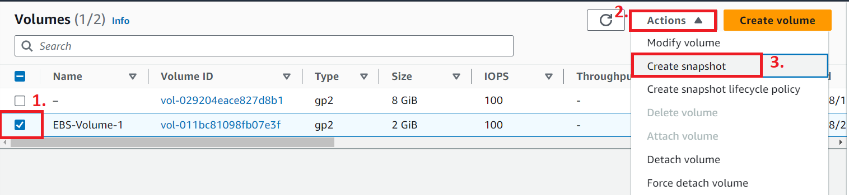

**Step 2: Choose the “Description”** as **“EBS-Volume-1-Snapshot”** & **click** on the **“Create snapshot”.**

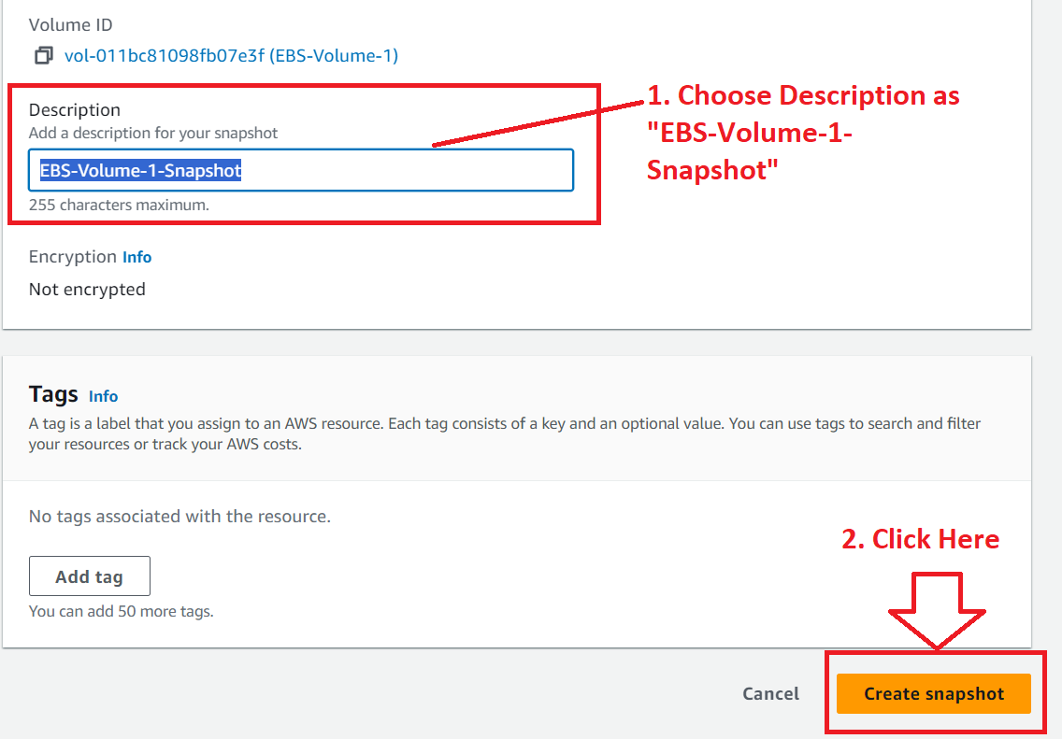

**Step 3: Your EBS Volume snapshot** has been **successfully created.**

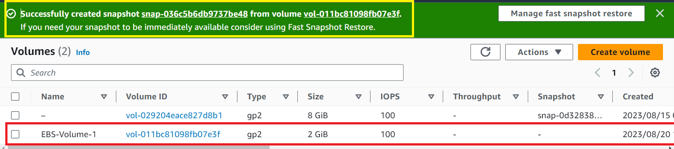

**It** means **your EBS-Volume-1 backup** has been **successfully created.**

**Step 4: Click** on the “**Snapshot hyperlink (**[**snap-036c5b6db9737be48**](https://us-east-1.console.aws.amazon.com/ec2/home?region=us-east-1#SnapshotDetails:snapshotId=snap-036c5b6db9737be48)**)”** & **all** the **snapshot details** will be **shown.**

